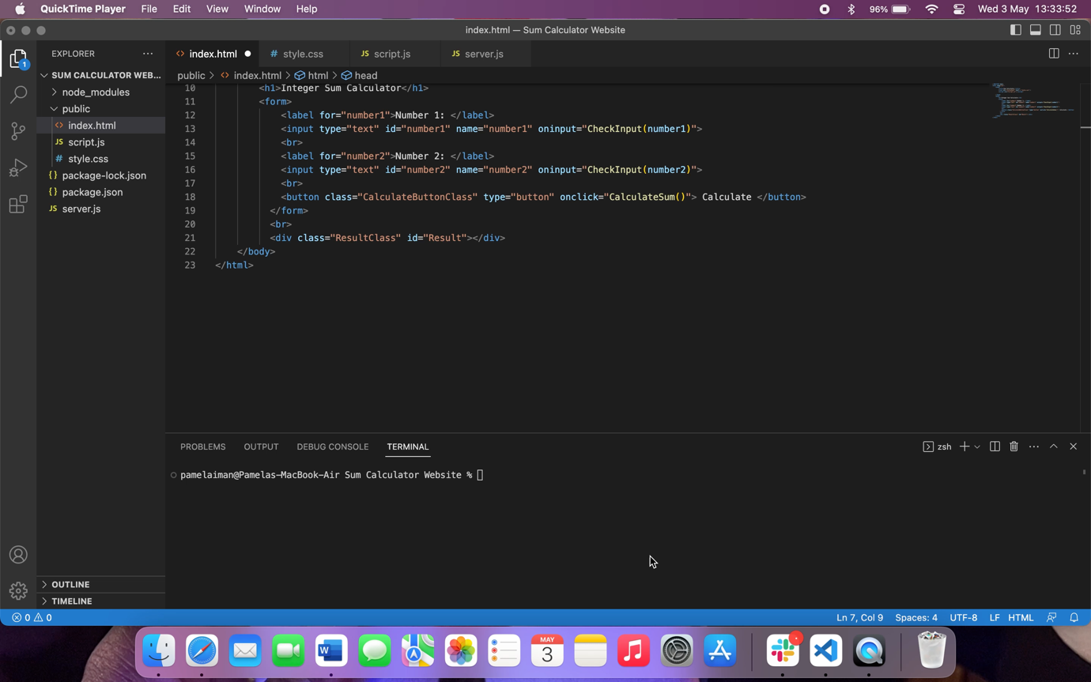**SCREEN RECORDING OF HTML URL IN ACTION**

**SCREENSHOT OF FILE CONTENT**

**

server.js file (JavaScript App)

index.html (HTML website) file

style.css file (CSS Styling sheet)

script.js (JavaScript) file